Point and Line Duality: NOTES

* If the source is the same and we increase the distance between source and destination, then the duals are also the same.

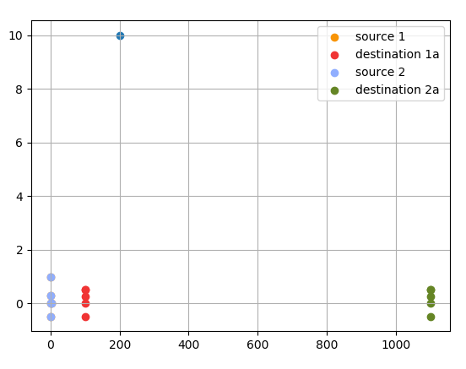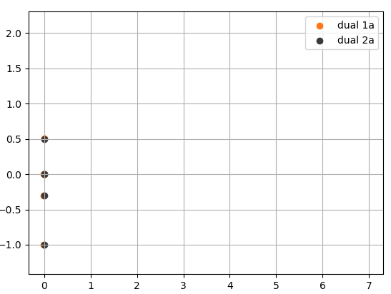

* When radius is 100

- Y coordinates are from [-1.0,0.5]

- length 1.5

- source here is at (0,0)

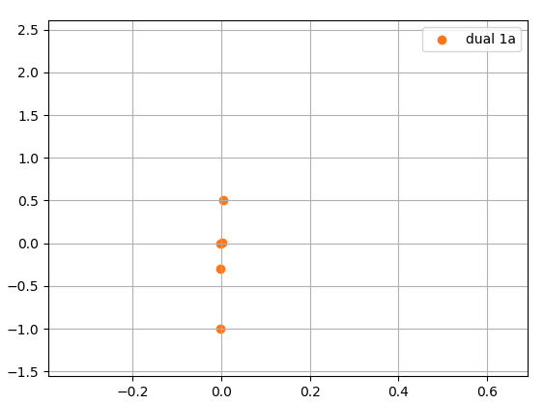

* Radius 100

- source2 is at (100,0) destination 2 is at (200,0)

- Y coordinate ranges from [-1.5,1.5]

- length 3

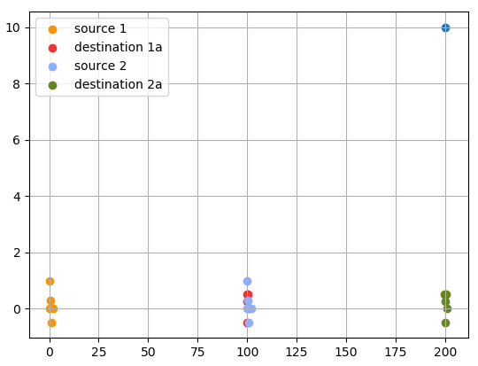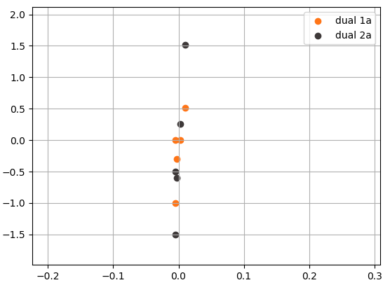

* Radius 100

- source2 is at (200,0) and destination2 is at (300,0)

- Y coordinate ranges from [-2,2.5]

- length 4.5

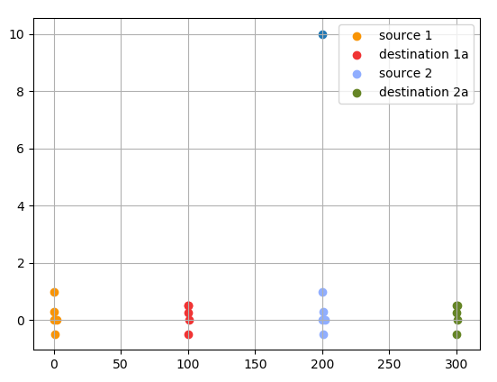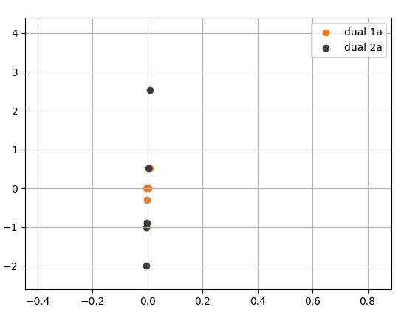

* Radius 100

- source2 is at (500,0) and destination2 is at (600,0)

- Y coordinate ranges from [-3.8,5.8]

- length (9.6)

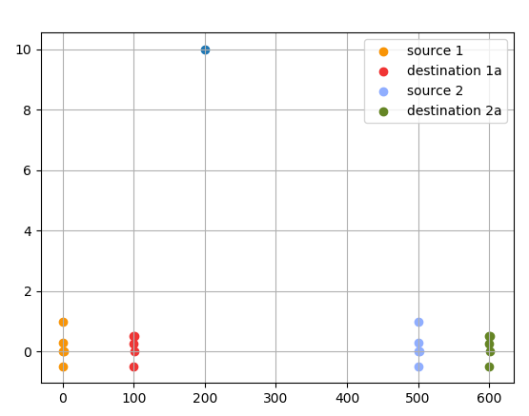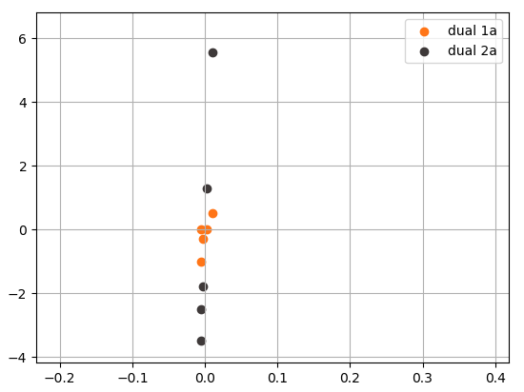

* Radius 100

- source2 is at (1000,0) and destination2 is at (1100,0)

- Y coordinate ranges from [-6,10.5]

- length (16.5)

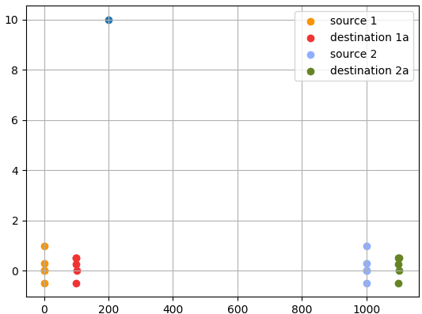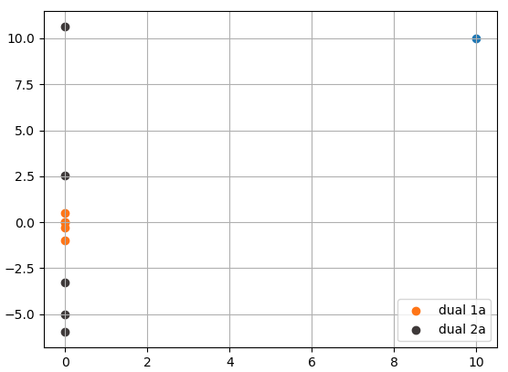

* Radius 100

- source is at (0,10)

- Y coordinate ranges from [-11,-9.5]

- length (1.5)

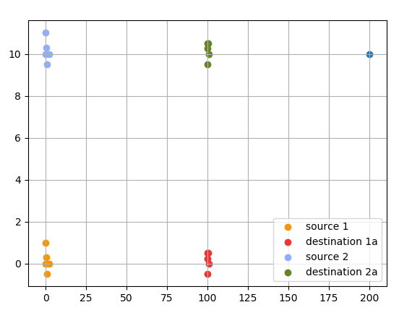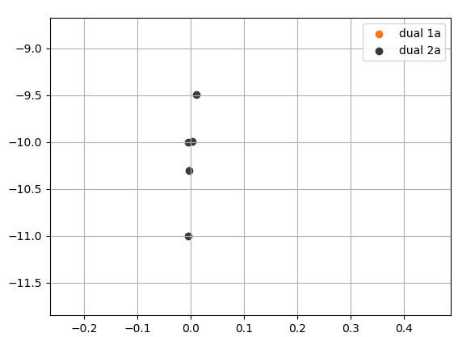

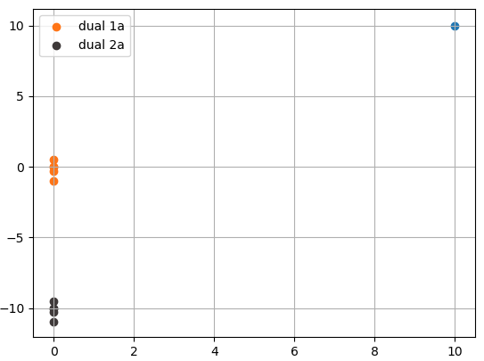

At this stage is we increase the x coordinates the y coordinates of the dual will spread around y = -10

But the x coordinates will remain the same.

* Radius 100

- source1 is at (0,0) and destination 1 is at (100,0)

- source 2 is at (500,100) and destination2 is at (600,10)

- The dual in y coordinates ranges from [-13.5,3.5]

-Length 14

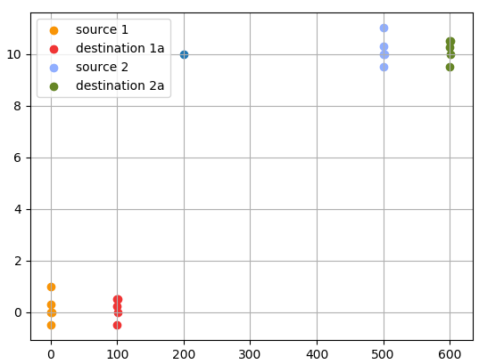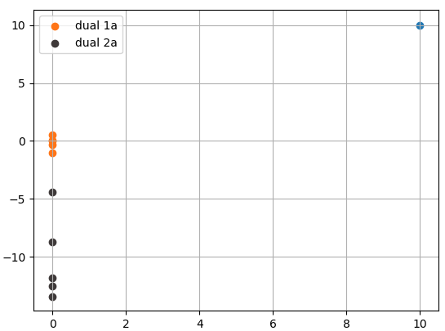

* Radius 100

- source 1 is at (0,0) destination1 is at (100,0)

- source 2 is at (10,0) detination2 is at (110,0)

- source 3 is at (90,0) destination3 is at (190,0)

- This is of the from O1…..O2………D1……D2

- duals are in the range of [-1.5 to 1.5] in y coordinates. Length 3

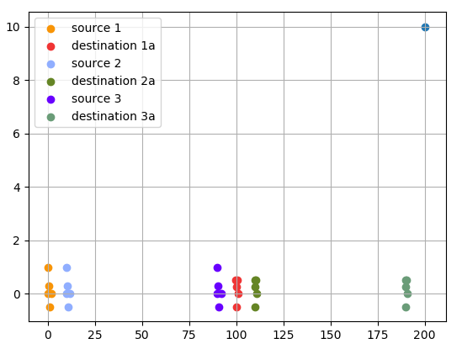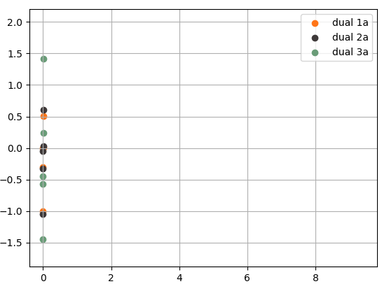

* Radius 100

- source 1 is at (0,0) destination1 is at (100,0)

- source 2 is at (10,0) detination2 is at (110,0)

- source 3 is at (90,0) destination3 is at (190,0)

- This is of the from O1…..O2………D1……D2

- source 4 is at (100,0) destination3 is at (200,0)

- This is of the from O1….D1….O2….D2

- duals are in the range of [-1.5 to 1.5] in y coordinates

- length 3

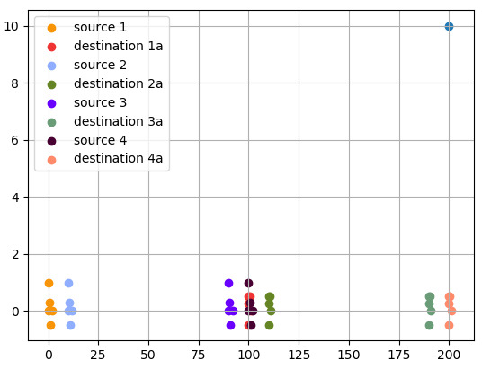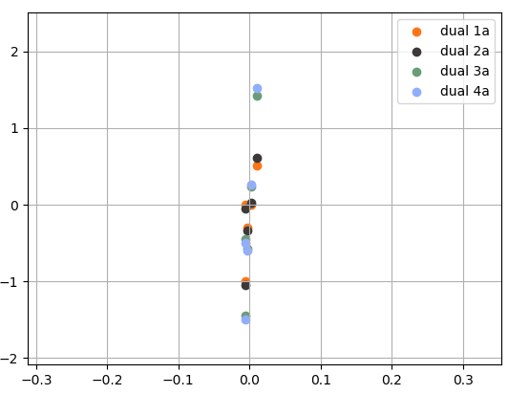

* Source1 radius 100
* Source2 (10,0) and destination2 (90,0)
* Radius of source 2 is 80
* This is of the from O1…..O2………D2……D2
* duals are in the range of [-1.1 , 0.6] in y coordinates
* length 1.7

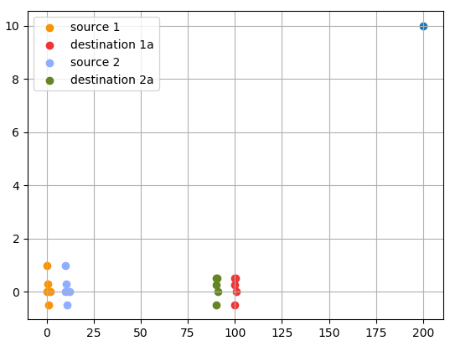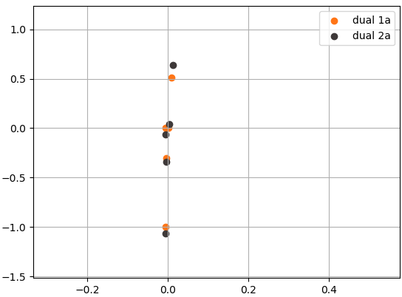

* Source 1 radius 100
* Source2 (20,0) and detinaion2 (70,0)
* Source2 radius 50
* This is of the from O1…..O2………D2……D1
* duals are in the range of [-1.2 , 0.9] in y coordinates
* length 2.1

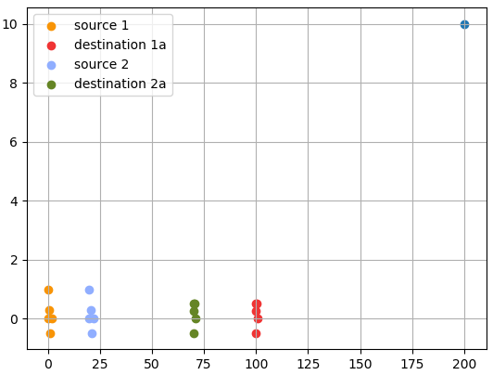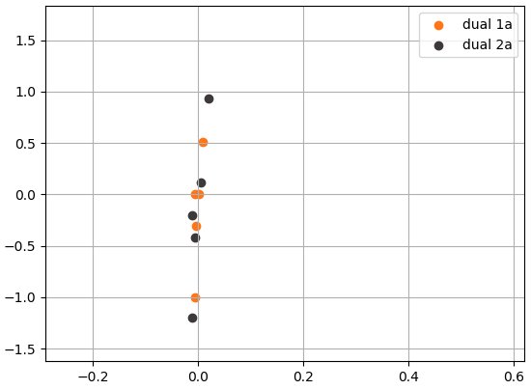

* Source 1 radius 100
* Source2 (30,0) and destination2 (60,0)
* Radius of source2 30
* This is of the from O1…..O2………D2……D1
* duals are in the range of [-1.5 , 1.5] in y coordinates
* length 3

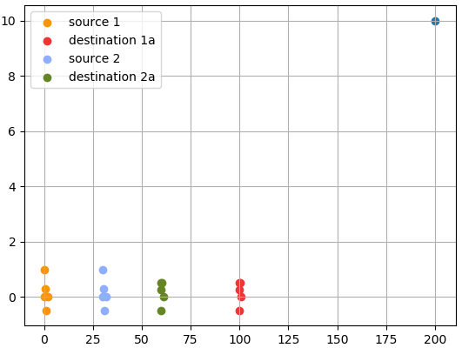 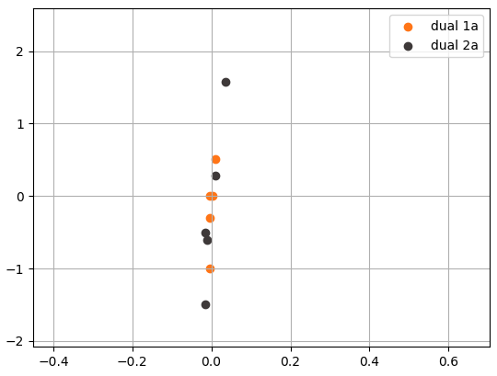

So, as the distance between source2 and destination 2 decreases the spread of the duals in y axis increases.

* Source 1 radius 100
* Source2 (130,0) and destination2 (160,0)
* Radius of source2 30
* This is of the from O1…..D1………O2……D2
* duals are in the range of [-3.5 , 5] in y coordinates
* length 8.5

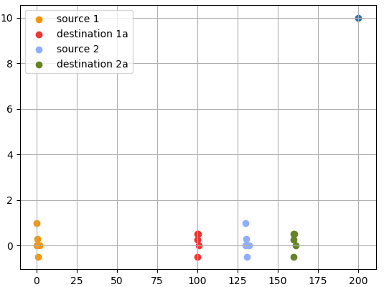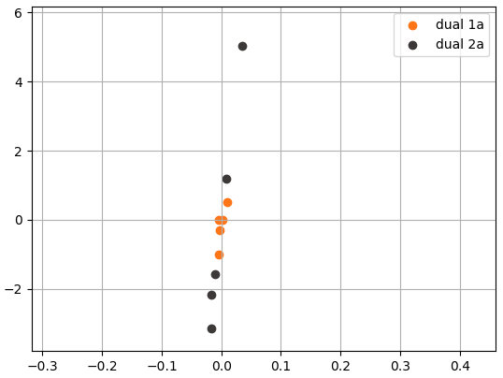

* Source 1 radius 100
* Source2 (330,0) and destination2 (360,0)
* Radius of source2 30
* This is of the from O1…..D1………O2……D2
* duals are in the range of [-6.25 ,12.5] in y coordinates
* length 18.75

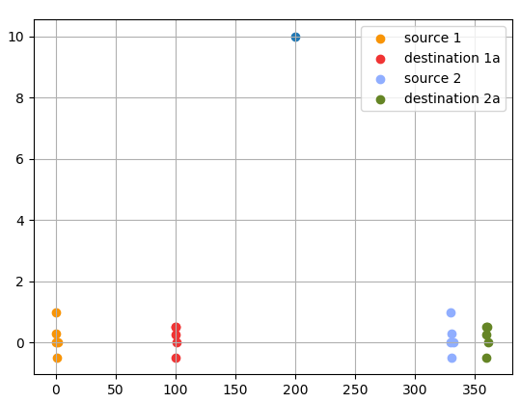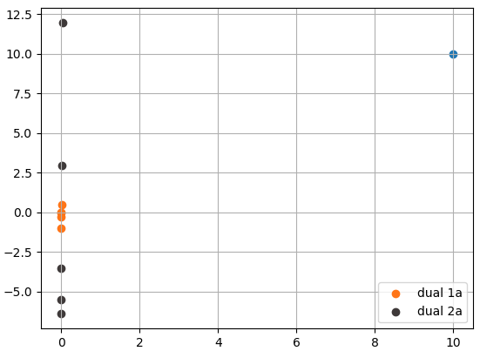

* Source 1 radius 100
* Source2 (40,0) and destination2 (140,0)
* Radius of source2 100
* This is of the from O1…..O2………D1……D2
* duals are in the range of [-1.2 , 0.9] in y coordinates
* length 2.1

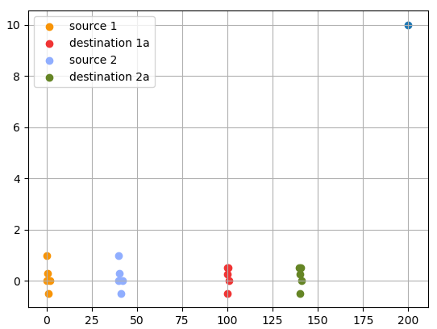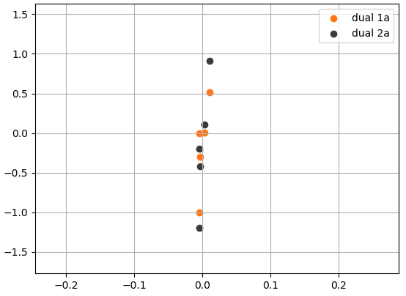

* Source 1 radius 100
* Source2 (40,0) and destination2 (140,0)
* Radius of source2 100
* This is of the from O1…..O2………D1……D2
* duals are in the range of [-1.5 , 1.5] in y coordinates
* length 3

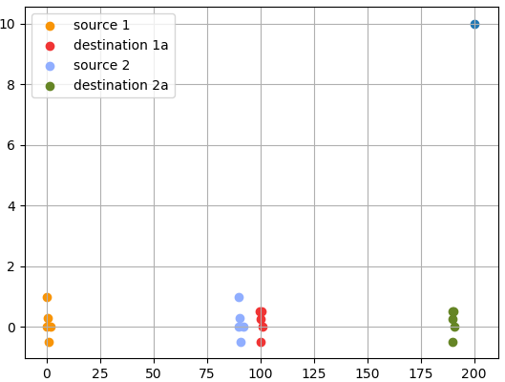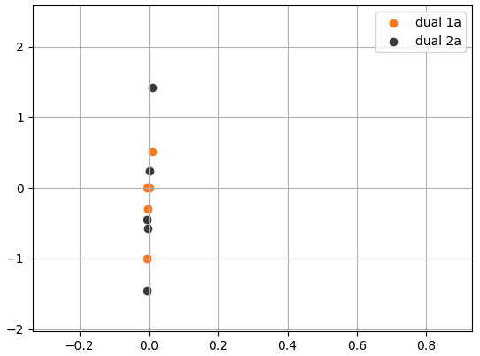

* Source 1 radius 100
* Source2 (90,0) and destination2 (140,0)
* Radius of source2 50
* This is of the from O1…..O2………D1……D2
* duals are in the range of [-2 , 2.5] in y coordinates
* length 4.5

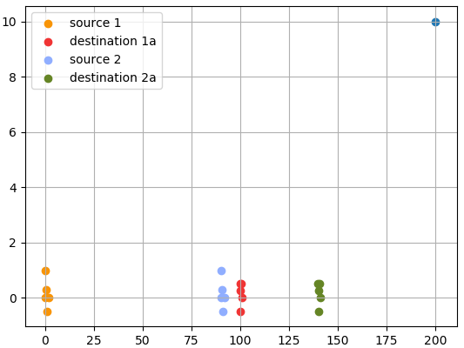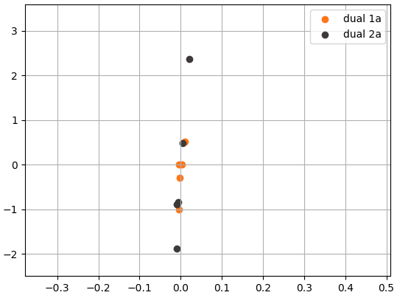

* Source 1 radius 100
* Source2 (90,0) and destination2 (120,0)
* Radius of source2 30
* This is of the from O1…..O2………D1……D2
* duals are in the range of [-2 , 3.7] in y coordinates
* length 5.7

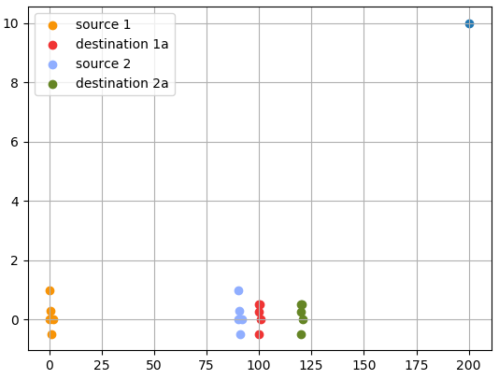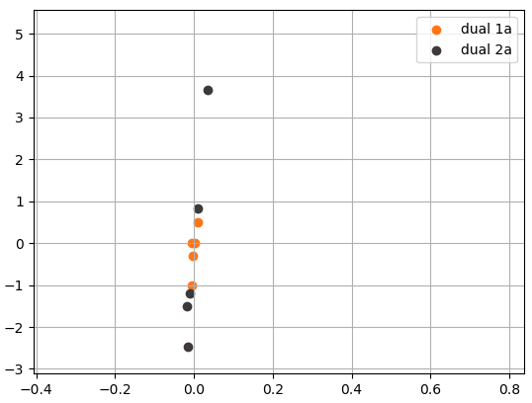

So, as the radius of source2 and destination2 gets smaller, the range of y coordinates in the duality keeps on increasing.

* Radius 1000

- source 1 is at (0,0) destination1 is at (1000, 0)

- source 2 is at (100,0) destination2 is at (1100,0)

- source 3 is at (900,0) destination 3 is at (1900,0)

- This is of the from O1…..O2………D1……D2

- duals are in the range of [-1.5 to 1.5] in y coordinates

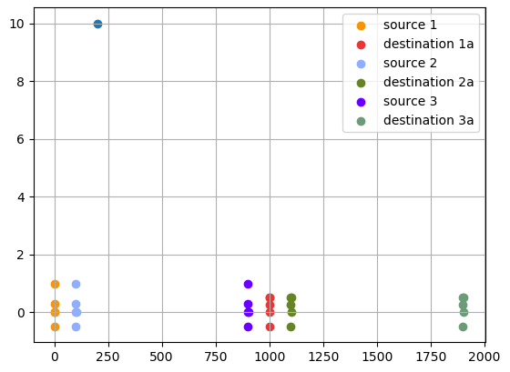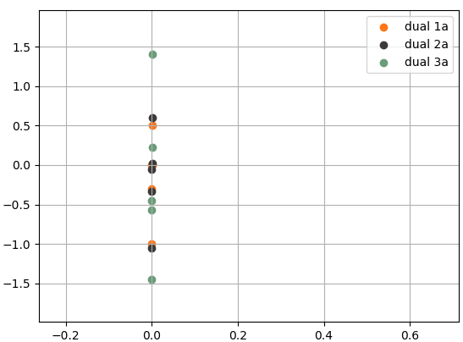

* Source 1 is at (0,0) with Radius 1000

- source 2 is at (1100,0) destination2 is at (2100,0). Radius 1000

- This is of the from O1…..D1.……O2……D2

- duals are in the range of [-1.5 to 1.6] in y coordinates. Length 3.1

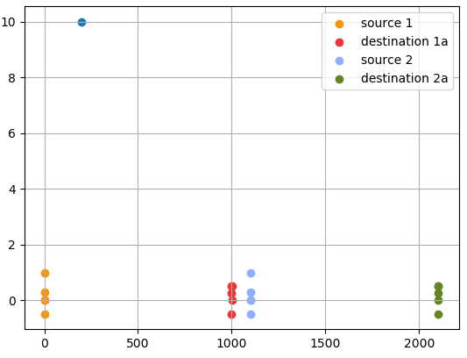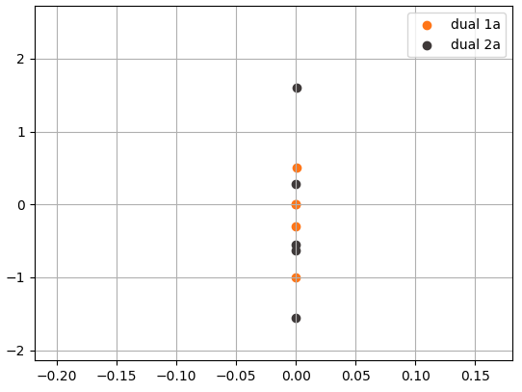

* Source 1 is at (0,0) with Radius 1000

- source 2 is at (2100,0) destination2 is at (3100,0). Radius 1000

- This is of the from O1…..D1.……O2……D2

- duals are in the range of [-2 to 2.5] in y coordinates. Length 4.5

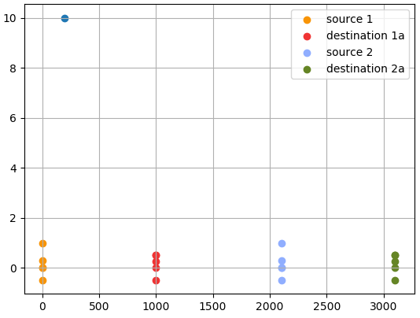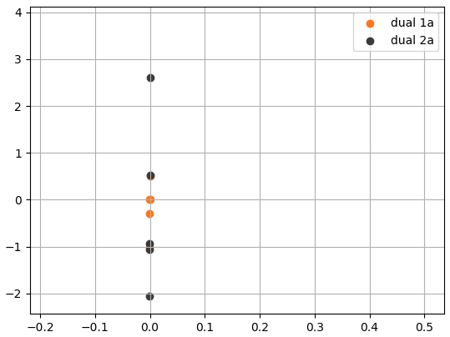

* Source 1 is at (0,0) with Radius 1000

- source 2 is at (5100,0) destination2 is at (6100,0). Radius 1000

- This is of the from O1…..D1.……O2……D2

- duals are in the range of [-3.8 to 5.8] in y coordinates. Length 9.6

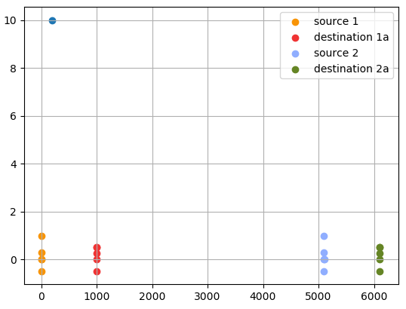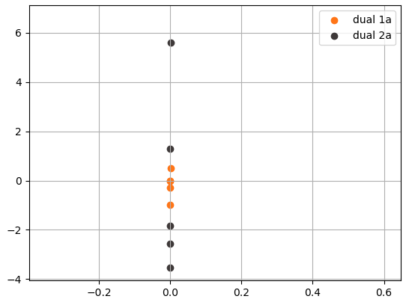

* Source 1 is at (0,0) with Radius 1000

- source 2 is at (5100,0) destination2 is at (5200,0). Radius 100

- This is of the from O1…..D1.……O2……D2

- duals are in the range of [-28,52] in y coordinates. Length 80

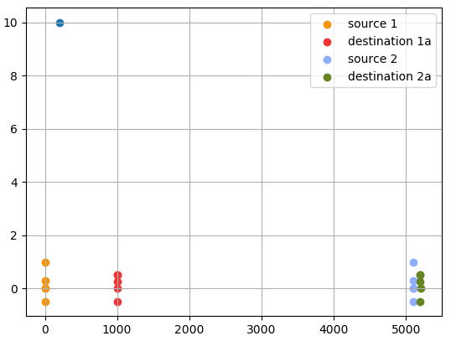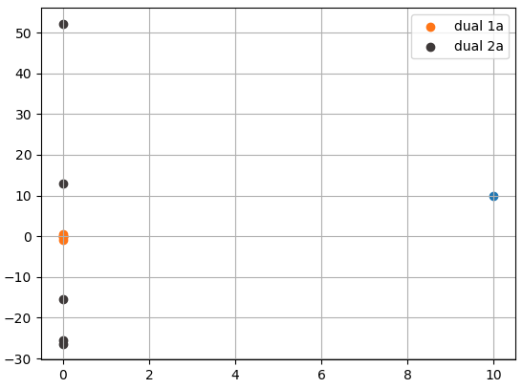

* Source 1 is at (0,0) with Radius 1000

- source 2 is at (1100,0) destination2 is at (1200,0). Radius 100

- This is of the from O1…..D1.……O2……D2

- duals are in the range of [-3.8,6] in y coordinates. Length 9.8

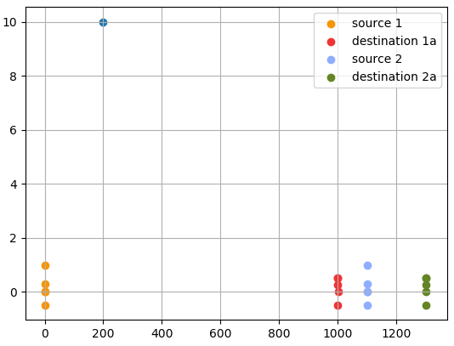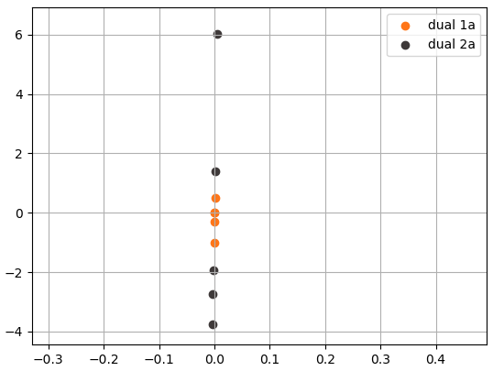

* Source 1 is at (0,0) with Radius 1000

- source 2 is at (100,0) destination2 is at (900,0). Radius 800

- This is of the from O1…..O2.……D2……D1

- duals are in the range of [-1,0.6] in y coordinates. Length 1.6

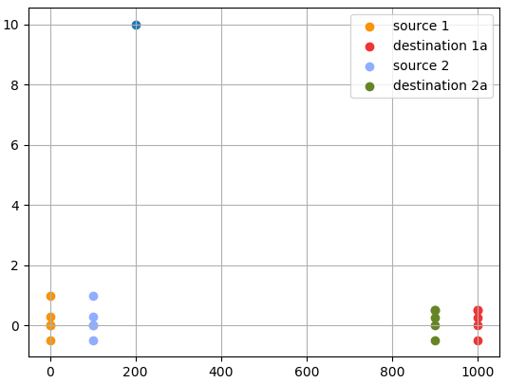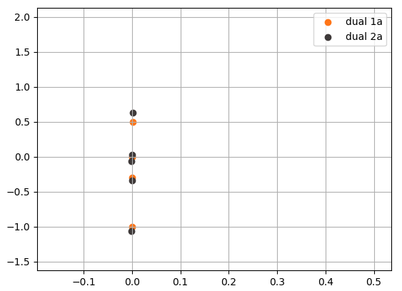

* Source 1 is at (0,0) with Radius 1000

- source 2 is at (300,0) destination2 is at (700,0). Radius 400

- This is of the from O1…..O2.……D2……D1

- duals are in the range of [-1.5,1.25] in y coordinates. Length 2.75

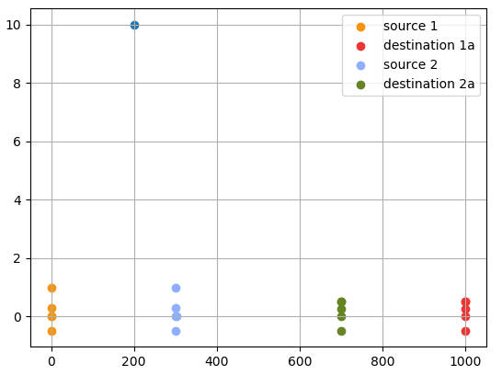 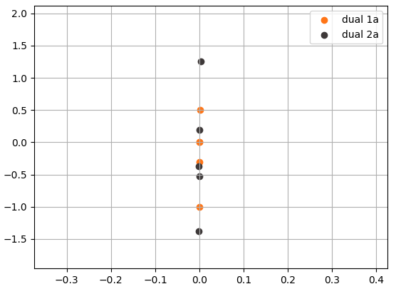

* Source 1 is at (0,0) with Radius 1000

- source 2 is at (400,0) destination2 is at (500,0). Radius 100

- This is of the from O1…..O2.……D2……D1

- duals are in the range of [-3,4.5] in y coordinates. Length 7.5

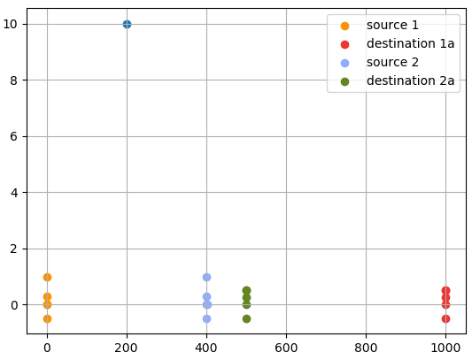 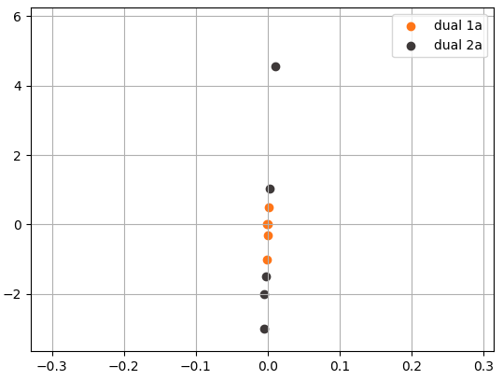

* Source 1 is at (0,0) with Radius 1000

- source 2 is at (100,0) destination2 is at (200,0). Radius 100

- This is of the from O1…..O2.……D2……D1

- duals are in the range of [-1.5,1.5] in y coordinates. Length 3

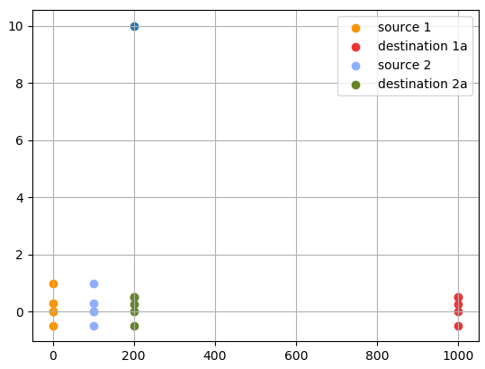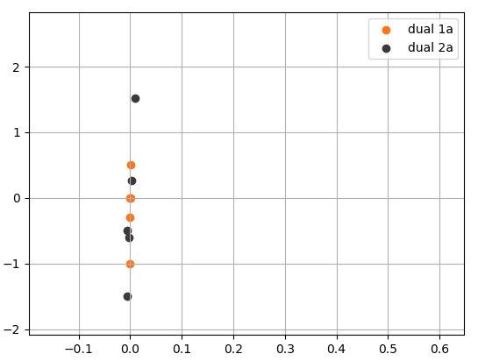

* Source 1 is at (0,0) with Radius 1000

- source 2 is at (700,0) destination2 is at (900,0). Radius 100

- This is of the from O1…..O2.……D2……D1

- duals are in the range of [-3,4] in y coordinates. Length 7

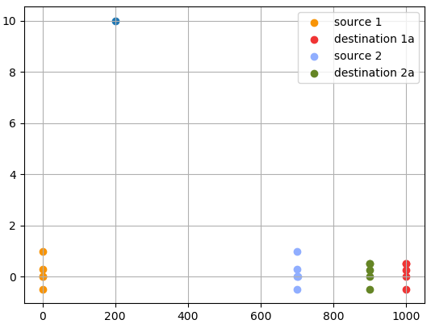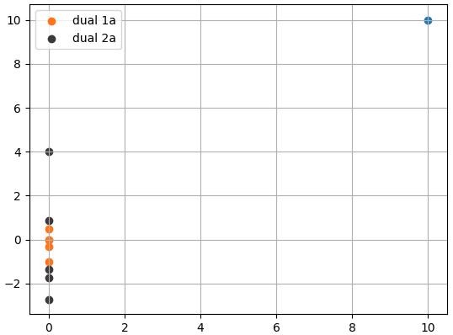

* Source 1 is at (0,0) with Radius 1000

- source 2 is at (500,0) destination2 is at (1100,0). Radius 600

- This is of the from O1…..O2.……D1……D2

- duals are in the range of [-1.5,1.5] in y coordinates. Length 3

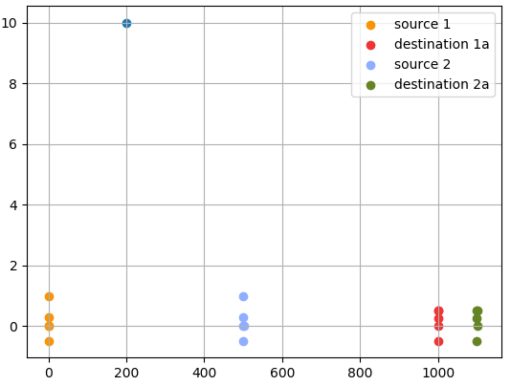 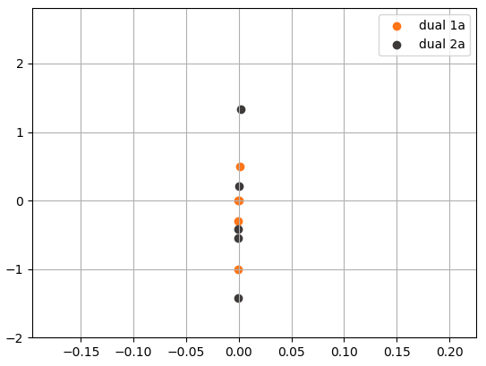

* Source 1 is at (0,0) with Radius 1000

- source 2 is at (000,0) destination2 is at (1100,0). Radius 200

- This is of the from O1…..O2.……D1……D2

- duals are in the range of [-3.5,5] in y coordinates. Length 8.5

